Week 7 REACT

9.React HOL:

ListOfPlayers.js  
// src/components/ListOfPlayers.js

import React from 'react';

const ListOfPlayers = () => {

const players = [

{ name: 'Virat', score: 85 },

{ name: 'Rohit', score: 95 },

{ name: 'Dhoni', score: 60 },

{ name: 'Rahul', score: 45 },

{ name: 'Hardik', score: 76 },

{ name: 'Jadeja', score: 90 },

{ name: 'Shami', score: 50 },

{ name: 'Bumrah', score: 30 },

{ name: 'Gill', score: 88 },

{ name: 'Surya', score: 20 },

{ name: 'Kuldeep', score: 70 },

];

// Filter using arrow function

const lowScorers = players.filter(player => player.score < 70);

return (

<div>

<h2>All Players (Name - Score)</h2>

<ul>

{players.map((player, index) => (

<li key={index}>{player.name} - {player.score}</li>

))}

</ul>

<h3>Players with score below 70:</h3>

<ul>

{lowScorers.map((player, index) => (

<li key={index}>{player.name} - {player.score}</li>

))}

</ul>

</div>

);

};

export default ListOfPlayers;  
  
IndianPlayers.js  
// src/components/IndianPlayers.js

import React from 'react';

const IndianPlayers = () => {

const team = ['Virat', 'Rohit', 'Dhoni', 'Rahul', 'Hardik', 'Jadeja'];

// Destructuring for odd/even team members

const [p1, p2, p3, p4, p5, p6] = team;

const oddTeam = [p1, p3, p5];

const evenTeam = [p2, p4, p6];

// Merge T20 and Ranji players using spread operator

const T20players = ['Gill', 'Surya'];

const RanjiTrophyPlayers = ['Pujara', 'Saha'];

const allPlayers = [...T20players, ...RanjiTrophyPlayers];

return (

<div>

<h2>Odd Team Players</h2>

<ul>

{oddTeam.map((name, index) => <li key={index}>{name}</li>)}

</ul>

<h2>Even Team Players</h2>

<ul>

{evenTeam.map((name, index) => <li key={index}>{name}</li>)}

</ul>

<h2>Merged T20 & Ranji Trophy Players</h2>

<ul>

{allPlayers.map((name, index) => <li key={index}>{name}</li>)}

</ul>

</div>

);

};

export default IndianPlayers;

App.js  
// src/App.js

import React from 'react';

import ListOfPlayers from './components/ListOfPlayers';

import IndianPlayers from './components/IndianPlayers';

function App() {

const flag = true; // Toggle this to false to show IndianPlayers

return (

<div className="App">

<h1>🏏 Cricket App</h1>

{flag ? <ListOfPlayers /> : <IndianPlayers />}

</div>

);

}

export default App;  
  
Output:

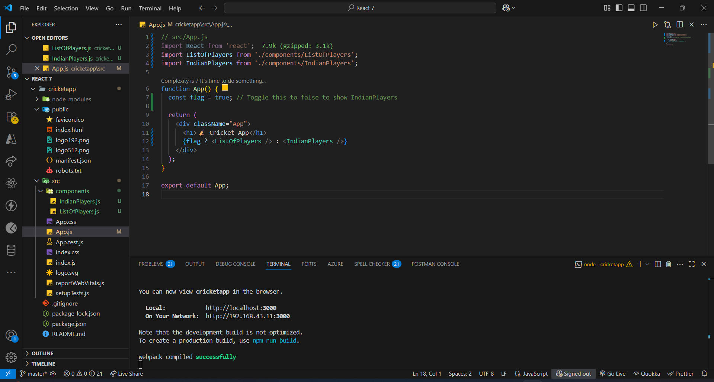

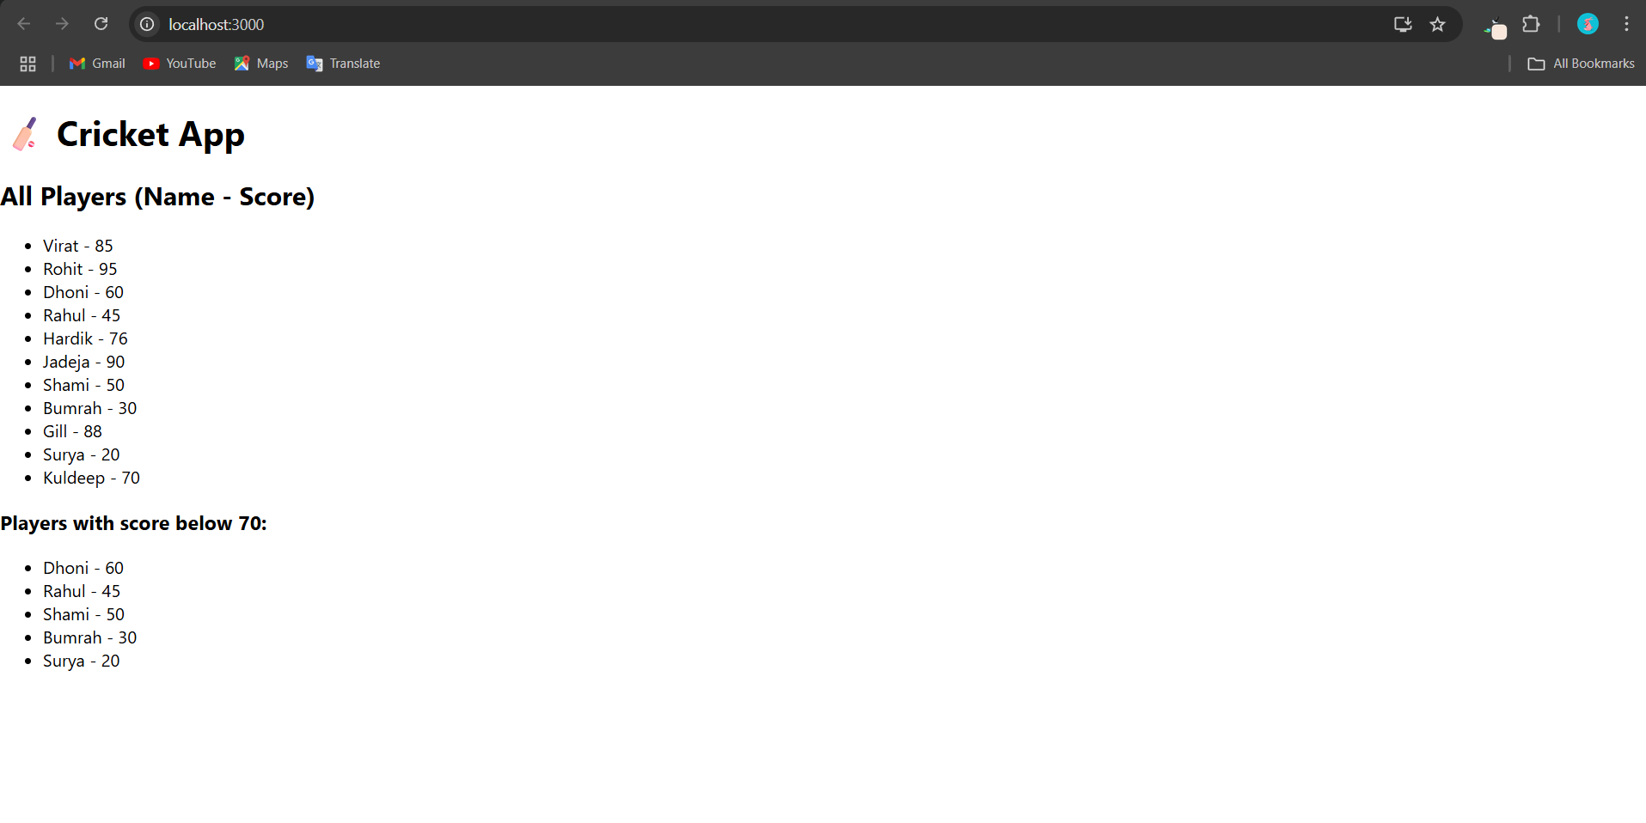

10.React HOL:

App.js  
// src/App.js

import React from "react";

import "./App.css";

function App() {

// Step 3: Create office list

const officeSpaces = [

{

id: 1,

name: "Tech Park Office",

rent: 55000,

address: "123, Anna Nagar, Chennai",

image: "https://via.placeholder.com/250?text=Tech+Park+Office"

},

{

id: 2,

name: "Downtown Workspace",

rent: 75000,

address: "456, MG Road, Bangalore",

image: "https://via.placeholder.com/250?text=Downtown+Workspace"

},

{

id: 3,

name: "Skyline Business Center",

rent: 62000,

address: "789, Jubilee Hills, Hyderabad",

image: "https://via.placeholder.com/250?text=Skyline+Business+Center"

}

];

return (

<div className="App">

{/\* Step 1: Heading \*/}

<h1>Office Space Rental App</h1>

{/\* Step 4: Render list \*/}

<div className="office-list">

{officeSpaces.map((office) => (

<div className="office-card" key={office.id}>

<img src={office.image} alt={office.name} />

<h2>{office.name}</h2>

<p>{office.address}</p>

<p

className="rent"

style={{ color: office.rent > 60000 ? "green" : "red" }}

>

₹{office.rent}

</p>

</div>

))}

</div>

</div>

);

}

export default App;  
  
/\* src/App.css \*/

.App {

text-align: center;

font-family: Arial, sans-serif;

padding: 20px;

}

.office-list {

display: flex;

justify-content: center;

flex-wrap: wrap;

gap: 20px;

margin-top: 30px;

}

.office-card {

border: 1px solid #ddd;

border-radius: 10px;

padding: 15px;

width: 250px;

box-shadow: 0 0 10px rgba(0, 0, 0, 0.1);

}

.office-card img {

width: 100%;

border-radius: 8px;

}

.office-card h2 {

margin: 10px 0 5px;

}

.rent {

font-weight: bold;

font-size: 1.2rem;

}  
  
Output:

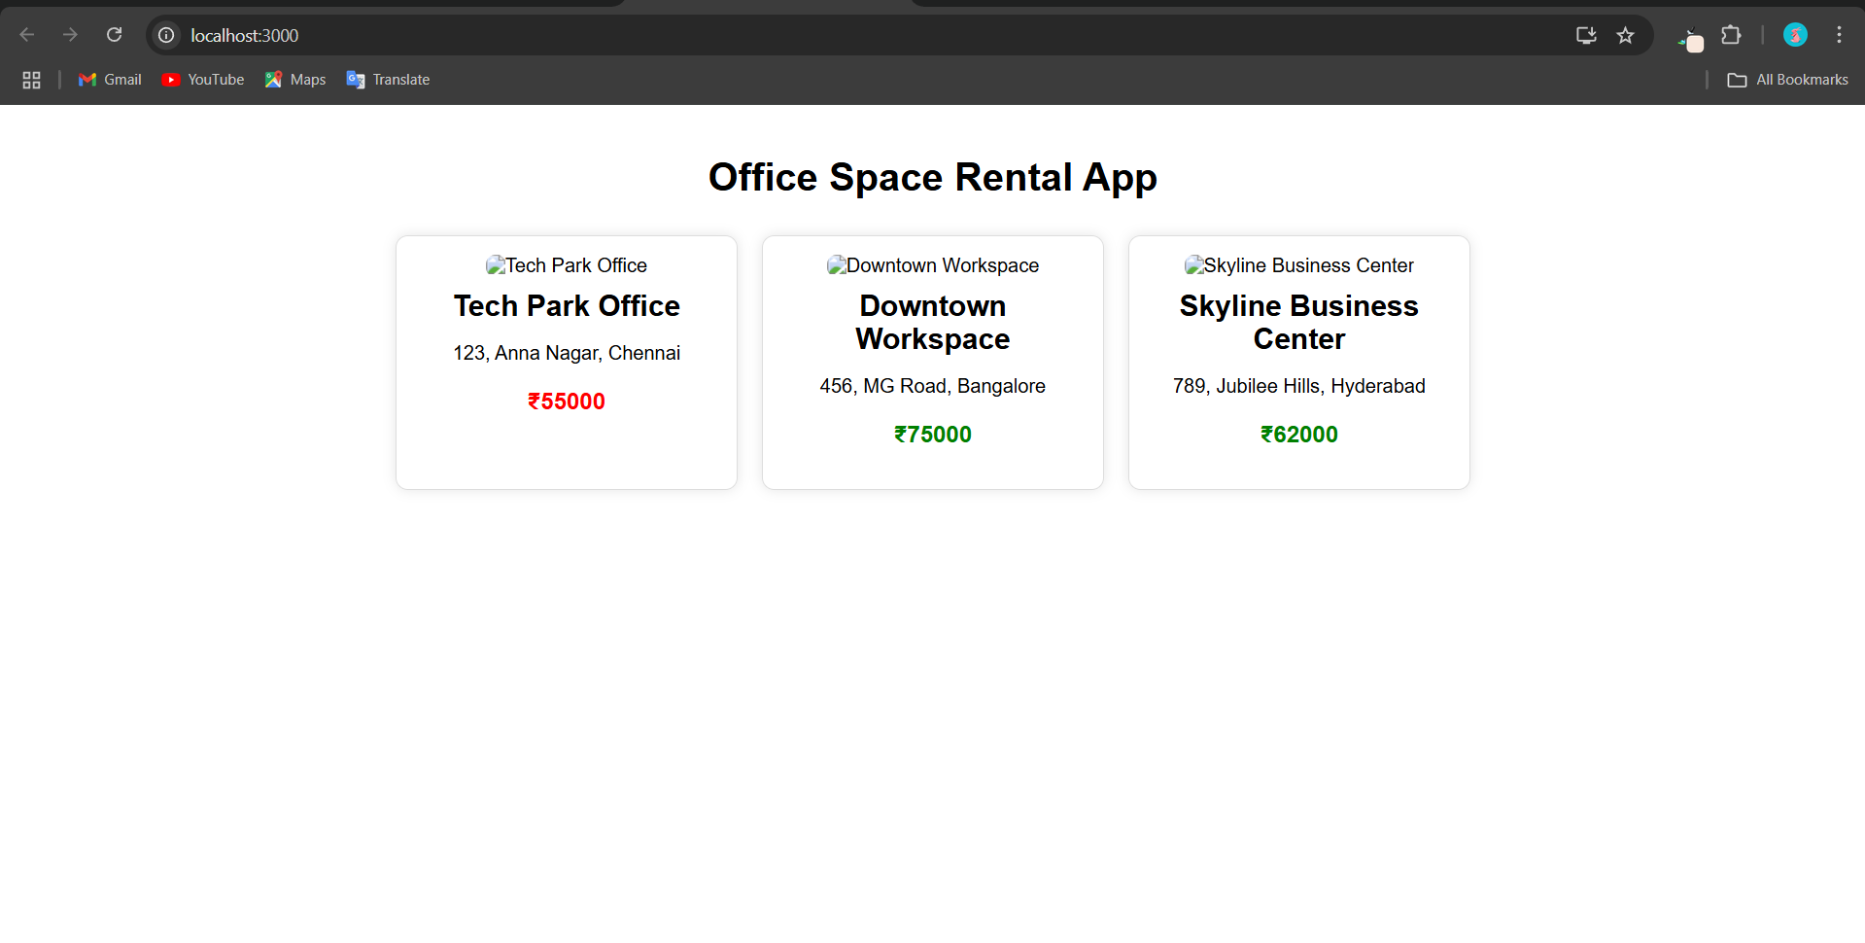

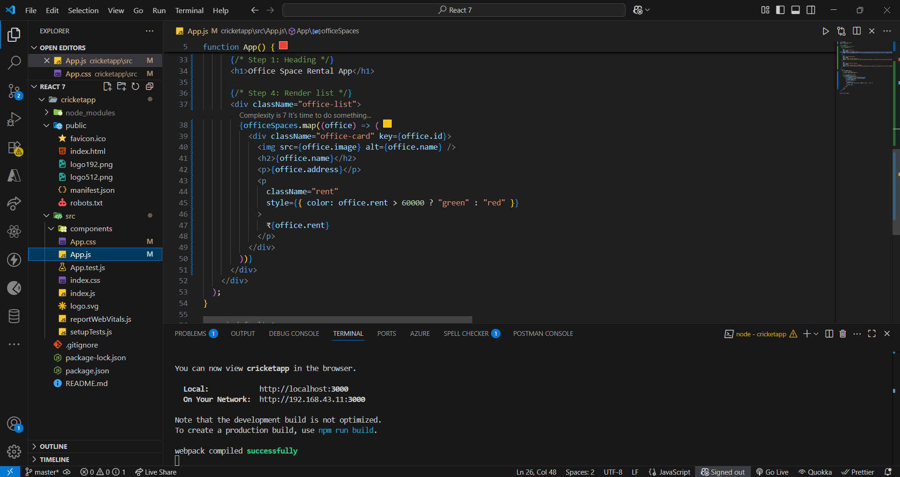

11.REACT HOL:

App.js  
// src/App.js

import React, { useState } from "react";

import CurrencyConvertor from "./CurrencyConvertor";

import "./App.css";

function App() {

const [count, setCount] = useState(0);

// Multiple methods for Increment

const handleIncrement = () => {

incrementValue();

sayHello();

};

const incrementValue = () => {

setCount(prev => prev + 1);

};

const sayHello = () => {

console.log("Hello! You clicked Increment.");

};

const handleDecrement = () => {

setCount(prev => prev - 1);

};

// Say Welcome Button

const sayWelcome = (message) => {

alert(message);

};

// Synthetic Event Example

const handleClick = (e) => {

alert("I was clicked");

};

return (

<div className="App">

<h1>React Event Examples App</h1>

<div className="counter-section">

<h2>Counter: {count}</h2>

<button onClick={handleIncrement}>Increment</button>

<button onClick={handleDecrement}>Decrement</button>

</div>

<div className="event-section">

<button onClick={() => sayWelcome("Welcome to the EventExamplesApp!")}>

Say Welcome

</button>

<button onClick={handleClick}>

OnPress (Synthetic Event)

</button>

</div>

<hr />

{/\* Currency Convertor Component \*/}

<CurrencyConvertor />

</div>

);

}

export default App;  
  
CurrencyConvertor.js

// src/CurrencyConvertor.js

import React, { useState } from "react";

function CurrencyConvertor() {

const [rupees, setRupees] = useState("");

const [euro, setEuro] = useState(null);

const handleSubmit = (e) => {

e.preventDefault();

const rate = 0.011; // Example conversion rate: ₹1 = €0.011

const converted = parseFloat(rupees) \* rate;

setEuro(converted.toFixed(2));

};

return (

<div className="currency-converter">

<h2>Currency Convertor (INR → EUR)</h2>

<form onSubmit={handleSubmit}>

<input

type="number"

placeholder="Enter amount in INR"

value={rupees}

onChange={(e) => setRupees(e.target.value)}

/>

<button type="submit">Convert</button>

</form>

{euro !== null && (

<p>€ {euro}</p>

)}

</div>

);

}

export default CurrencyConvertor;  
  
App.css  
.App {

text-align: center;

font-family: Arial, sans-serif;

padding: 20px;

}

button {

margin: 10px;

padding: 10px 15px;

font-size: 16px;

cursor: pointer;

}

.counter-section,

.event-section,

.currency-converter {

margin-top: 30px;

}  
  
Output:

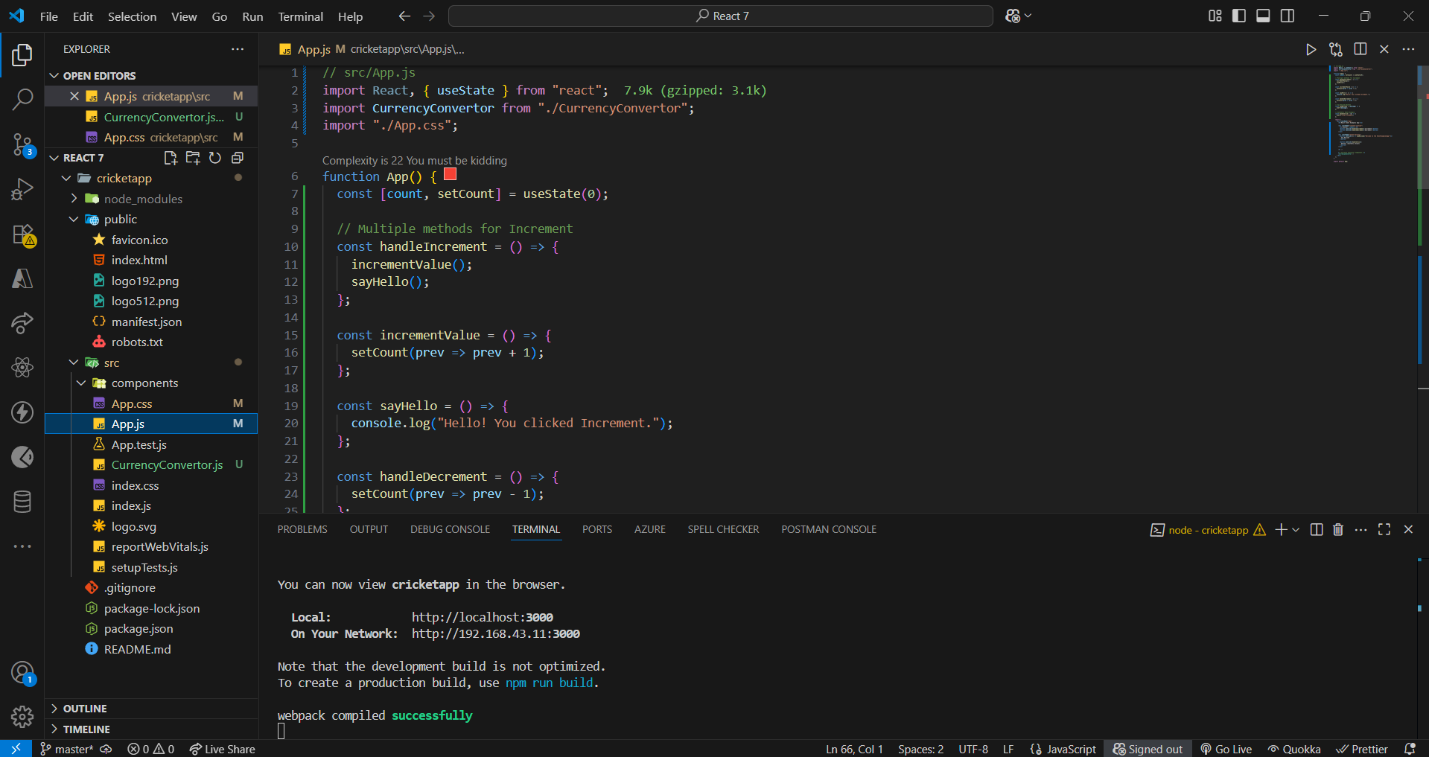

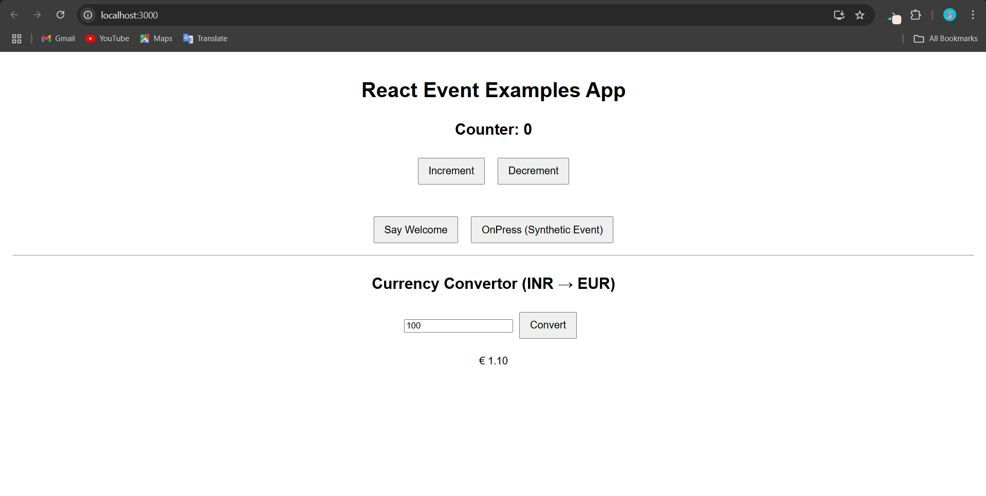  
  
  
  
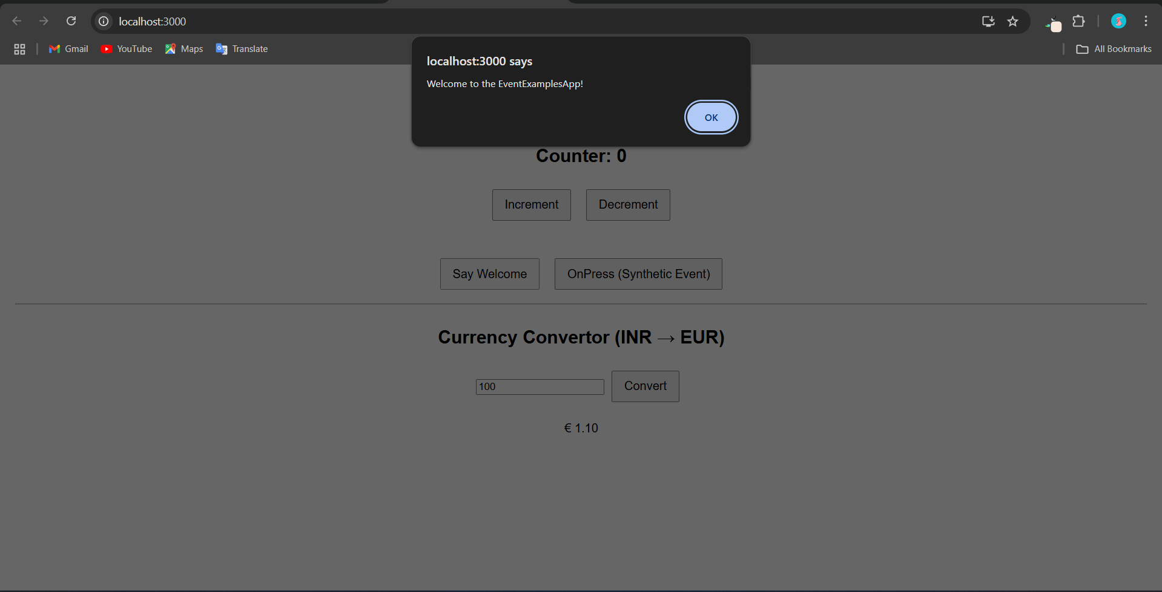

!2.REACT HOL:  
  
App.js

import React, { useState } from "react";

import GuestPage from "./GuestPage";

import UserPage from "./UserPage";

import "./App.css";

function App() {

const [isLoggedIn, setIsLoggedIn] = useState(false);

const handleLogin = () => setIsLoggedIn(true);

const handleLogout = () => setIsLoggedIn(false);

return (

<div className="App">

<header>

<h1>Flight Ticket Booking App</h1>

<div>

{isLoggedIn ? (

<button onClick={handleLogout}>Logout</button>

) : (

<button onClick={handleLogin}>Login</button>

)}

</div>

</header>

{isLoggedIn ? <UserPage /> : <GuestPage />}

</div>

);

}

export default App;  
  
GuestPage.js  
// src/GuestPage.js

import React from "react";

function GuestPage() {

const flights = [

{ id: 1, airline: "Air India", from: "Delhi", to: "Mumbai", time: "10:00 AM" },

{ id: 2, airline: "IndiGo", from: "Chennai", to: "Bangalore", time: "12:30 PM" },

{ id: 3, airline: "SpiceJet", from: "Kolkata", to: "Hyderabad", time: "3:15 PM" },

];

return (

<div>

<h2>Welcome, Guest!</h2>

<p>Please log in to book tickets.</p>

<h3>Available Flights</h3>

<ul>

{flights.map((flight) => (

<li key={flight.id}>

✈ {flight.airline} - {flight.from} to {flight.to} at {flight.time}

</li>

))}

</ul>

</div>

);

}

export default GuestPage;  
  
UserPage.js  
// src/UserPage.js

import React from "react";

function UserPage() {

const flights = [

{ id: 1, airline: "Air India", from: "Delhi", to: "Mumbai", time: "10:00 AM" },

{ id: 2, airline: "IndiGo", from: "Chennai", to: "Bangalore", time: "12:30 PM" },

{ id: 3, airline: "SpiceJet", from: "Kolkata", to: "Hyderabad", time: "3:15 PM" },

];

const handleBooking = (flightId) => {

alert(`Ticket booked successfully for flight ID: ${flightId}`);

};

return (

<div>

<h2>Welcome, User!</h2>

<h3>Book Your Flight</h3>

<ul>

{flights.map((flight) => (

<li key={flight.id}>

✈ {flight.airline} - {flight.from} to {flight.to} at {flight.time}{" "}

<button onClick={() => handleBooking(flight.id)}>Book</button>

</li>

))}

</ul>

</div>

);

}

export default UserPage;  
  
App.css:  
.App {

text-align: center;

font-family: sans-serif;

padding: 20px;

}

header {

display: flex;

justify-content: space-between;

align-items: center;

margin-bottom: 20px;

}

button {

padding: 8px 12px;

margin-left: 10px;

font-size: 16px;

cursor: pointer;

}  
  
  
  
Output:

